C01 AT- 3
Data Structures (Debugging)

Question - 1
The program below reads n integers into an array and should print the largest element, but it gives wrong output. Fix the bugs.
#include <stdio.h>
int main() {
int n, a[100], max = 0;
scanf("%d", &n);
for (int i = 0; i <= n; i++)
scanf("%d", &a[i]);
for (int i = 1; i < n; i++)
if (a[i] > max) max = a[i];
printf("%d", max);
return 0;
}
Input: n followed by n integers. Output: the maximum element.
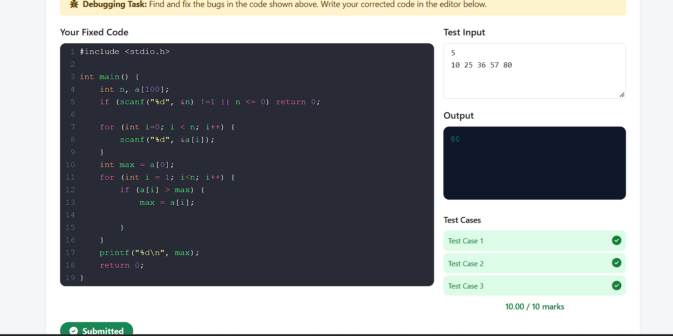

Question -2
The program below should search for a key in a sorted array using binary search and print its index (or -1 if not found), but it loops forever or misses elements. Fix the bugs.

#include <stdio.h>
int main() {
int n, a[100], key;
scanf("%d", &n);
for (int i = 0; i < n; i++) scanf("%d", &a[i]);
scanf("%d", &key);
int low = 0, high = n, ans = -1;
while (low < high) {
int mid = (low + high) / 2;
if (a[mid] == key) { ans = mid; break; }
else if (a[mid] < key) low = mid;
else high = mid - 1;
}
printf("%d", ans);
return 0;
}
Input: n, n sorted integers, then the key. Output: index of key or -1.
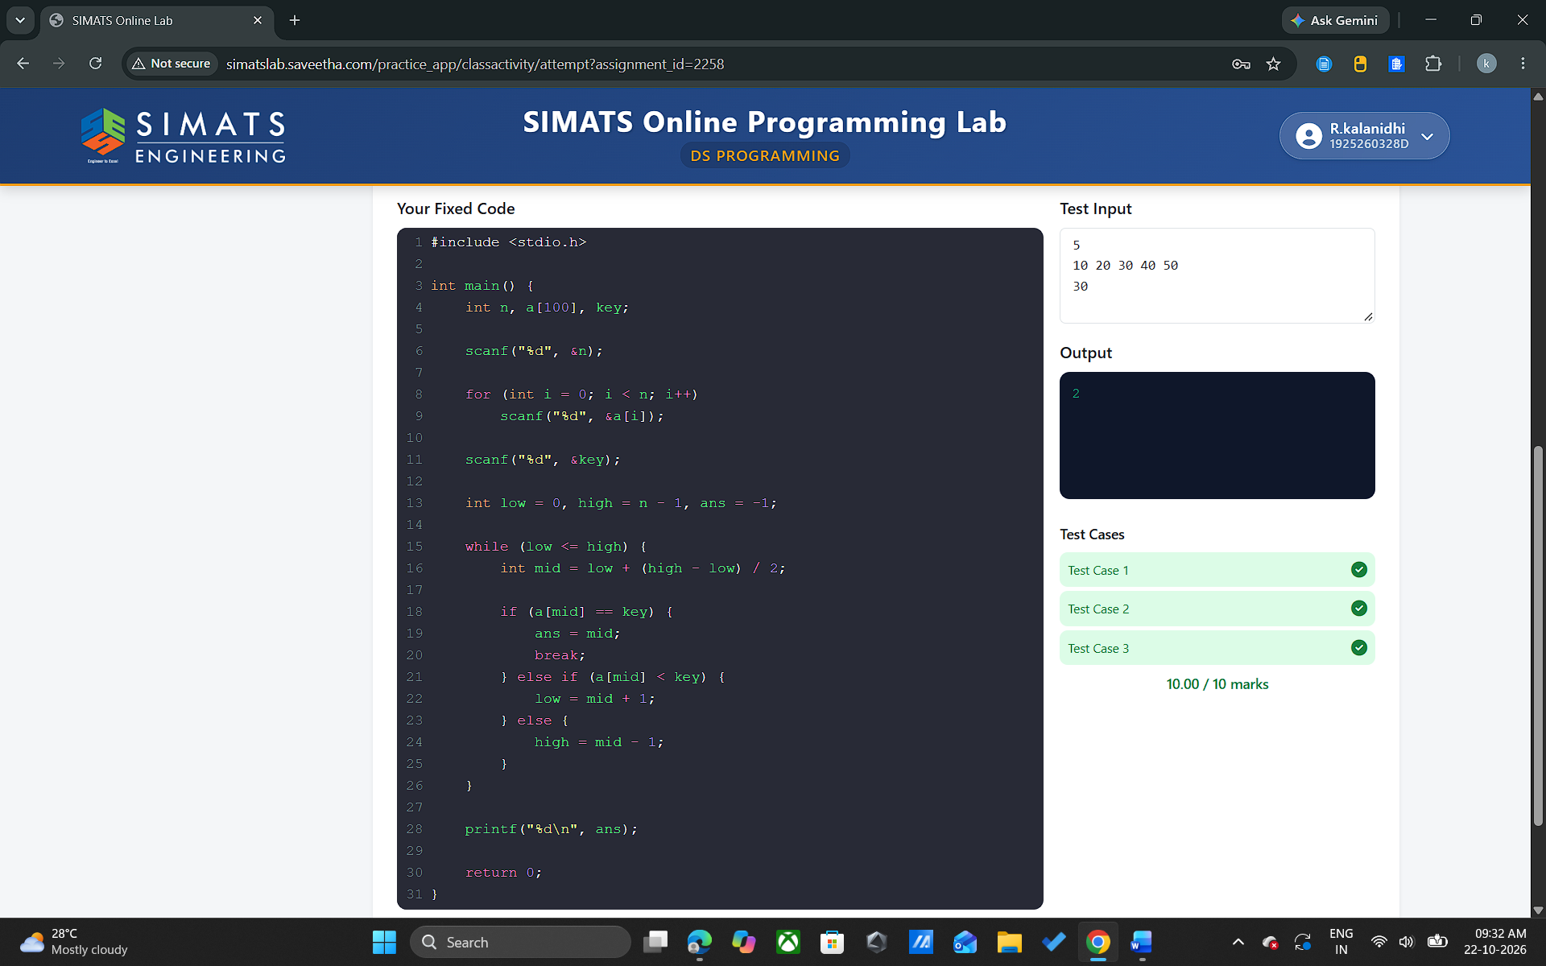

Question – 3
The program below pushes n integers onto a stack and then pops them all, printing each popped element followed by a space (so the output is in reverse order). It prints garbage values. Fix the bug.
#include <stdio.h>
int main() {
int n, x, stack[100], top = 0;
scanf("%d", &n);
for (int i = 0; i < n; i++) {
scanf("%d", &x);
stack[top++] = x;
}
while (top > 0)
printf("%d ", stack[top--]);
return 0;
}
Input: n followed by n integers. Output: elements popped from the stack, each followed by a space.
